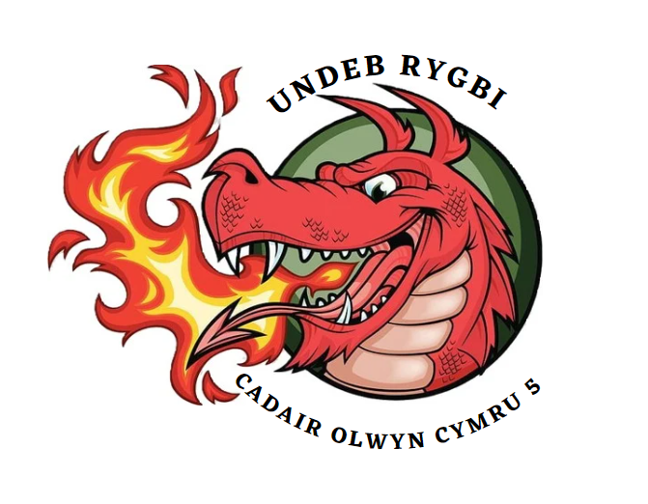
Anti-Bribery, Corruption & Fraud

1. Introduction
This policy sets out the steps all members of Wales 5s Wheelchair rugby Union must take to prevent bribery, corruption or fraud in our organisation and to comply with relevant legislation.
2. What are bribery, corruption and fraud?
Bribery
In reference to the Bribery Act 2010. Under the Act, it is illegal:
• to pay or offer to pay a bribe;
• to receive or agree to receive a bribe;
• to bribe a foreign public official;
• to fail to have adequate procedures in place to prevent bribery.
A bribe includes financial or other advantage such as gifts and hospitality, meals, entertainment or anything else of value or other advantage. An offence under the Bribery Act carries criminal penalties for individuals and organisations. For individuals, a maximum prison sentence of ten years and/or an unlimited fine can be imposed. It does not matter whether the act is done directly or indirectly or whether the bribery occurs in the UK or abroad.

Corruption
Any illegal, immoral or unethical activity that attempts to deliberately distort the result of a sporting contest for the material gain of one or more parties involved in that activity.

Fraud
Fraud is a wrongful or criminal deception intending to result in personal or financial gain. Wales 5s Wheelchair rugby Union is subject to the Fraud Act 2006 which creates a general offence of fraud and introduces three ways of committing it, namely.
- • Fraud by false representation;
- • Fraud by failure to disclose information when there is a legal duty to do so; and
- • Fraud by abuse of position.
In each case:
- • the persons conduct must be dishonest;
- • his/her intention must be to make a gain; or cause a loss or the risk of a loss to another.
- • No gain or loss needs actually to have been made.
- • The maximum sentence is 10 years' imprisonment.
Where the "person" in breach of the Act is a legal person (that is, a body corporate), those involved in its management who have consented to or connived in the offence are also guilty of the offence.

3. Who can be involved in bribery, corruption and fraud and in what circumstances?
Bribery, corruption and fraud may be committed by anyone involved with our club including any of our committee or Board members.

4. Zero tolerance of fraud, bribery and corruption
Our position is simple: we conduct our business to the highest legal and ethical standards. As a Club, we operate with honesty, impartiality and objectivity.
We will not be a party to bribery or corruption in any form and maintain a zero-tolerance approach to bribery, corruption and fraud by our members.
5. Conclusion
Anyone who is guilty of bribery, corruption and fraud in any form will be subject to disciplinary action, which may result in suspension and/or termination of their membership. If you believe that you have suffered detrimental treatment as a result of refusing to take part in bribery or corruption or because of reporting in good faith, you should inform the club Chair as you feel appropriate.

