 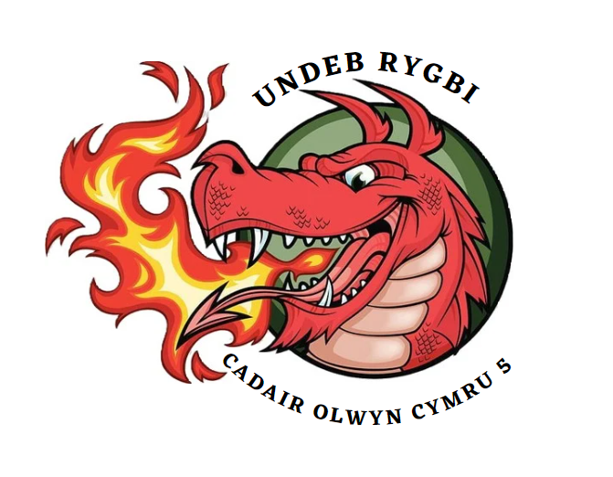

**Clean Club Commitment Statement**

Everyone has a duty to protect clean sport and **Wales 5s Wheelchair rugby union** recognises our role in developing, nurturing, and reinforcing a culture of clean sport.

**Wales 5s Wheelchair rugby union** agrees with Great Britain Wheelchair Rugby (GBWR) and UK Anti-Doping (UKAD) position that cheating, including doping, in sport is fundamentally contrary to the spirit of sport, undermining the otherwise positive impact of sport on society.

To protect the reputation of **Wales 5s Wheelchair rugby union** and Wheelchair Rugby, we commit to support clean sport in the following ways:

* **Wales 5s Wheelchair rugby union** is committed to encouraging fair play, ethical decision making and healthy behaviour in all athlete/participant members.
* All athlete/participant members will conduct themselves in line with the spirit of sport and the anti-doping rules.
* Volunteers and any associated staff will not condone, assist or in any way support doping behaviour.
* All members must abide by all **Wales 5s Wheelchair rugby union** policies and procedures and any breaches of these will be acted upon accordingly.
* **Wales 5s Wheelchair rugby union** recognises the importance of establishing a culture of ‘speaking out’ and encourages club members to do so either to a member of our club, directly to UKAD (intelligence@ukad.org.uk) or using the confidential Report Doping in Sport service (08000 32 23 32 or www.reportdoping.com)
* **Wales 5s Wheelchair rugby union** will uphold any sanctions placed upon an athlete or athlete support personnel by UKAD or other associated body in accordance with the World Anti-Doping Code
* **Wales 5s Wheelchair rugby union** will pass on any further anti-doping information that is received from GBWR or UKAD that is relevant to our members.
* Providing opportunities for our members to enhance their anti-doping knowledge and their ability to protect the integrity of **Wales 5s Wheelchair rugby union** and clean sport.

Further details about Wheelchair Rugby’s anti-doping programme in the UK can be found here <https://gbwr.org.uk/anti-doping/>

and more general information can be found on UKAD’s website here [www.ukad.org.uk](http://www.ukad.org.uk)

Justin Griffiths

CEO

01/04/2024